Multiple Inheritance

📌 Definition:
# Source: AI Source: Provided by: [Data Path: Persons Table -> ID Column: 1, Name_En Column: Motasem Essam] -> From: [ChatGPT] on [12/9/2025]
Multiple inheritance is a type of inheritance where a single child class inherits from more than one parent class.

🧠 Simple idea:
# Source: AI Source: Provided by: [Data Path: Persons Table -> ID Column: 1, Name_En Column: Motasem Essam] -> From: [ChatGPT] on [12/9/2025]
Multiple inheritance = “Many parents → One child” 👨‍👩‍👧‍👦➡️👦

🔍 Key characteristics:
# Source: AI Source: Provided by: [Data Path: Persons Table -> ID Column: 1, Name_En Column: Motasem Essam] -> From: [ChatGPT] on [12/9/2025]
- 🔗 A class can inherit from multiple parent classes
- ♻️ Combines features from different classes
- ➕ Child class can access methods/attributes from all parents
- ⚠️ Can create ambiguity problems (e.g., same method in multiple parents)
- ❗ Not supported directly in some languages like Java, but supported in C++

📌 Example (C++ style):
# Source: AI Source: Provided by: [Data Path: Persons Table -> ID Column: 1, Name_En Column: Motasem Essam] -> From: [ChatGPT] on [12/9/2025]
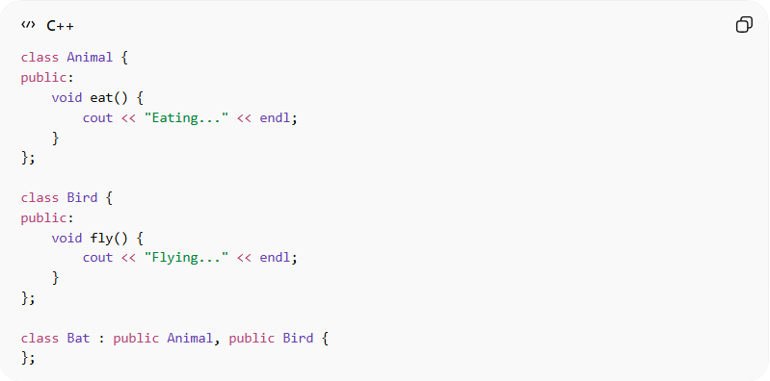
class Animal {
public:
void eat() {
cout << "Eating..." << endl;
}
};

class Bird {
public:
void fly() {
cout << "Flying..." << endl;
}
};

class Bat : public Animal, public Bird {
};

Usage:
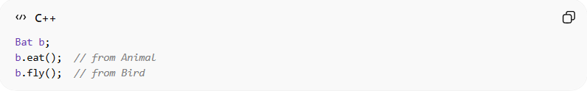
Bat b;
b.eat(); // from Animal
b.fly(); // from Bird

⚠️ Problem: Ambiguity (Diamond Problem)
# Source: AI Source: Provided by: [Data Path: Persons Table -> ID Column: 1, Name_En Column: Motasem Essam] -> From: [ChatGPT] on [12/9/2025]
If two parent classes have the same method:
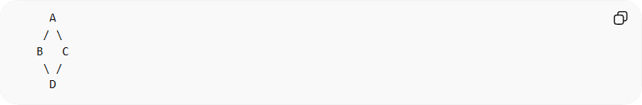
A
/ \
B C
\ /
D
👉 The child (D) may not know which method to use

⚙️ In languages like Java:
# Source: AI Source: Provided by: [Data Path: Persons Table -> ID Column: 1, Name_En Column: Motasem Essam] -> From: [ChatGPT] on [12/9/2025]
- ❌ Multiple inheritance is not directly allowed with classes
- ✅ Achieved using interfaces

🎯 Why multiple inheritance is useful:
# Source: AI Source: Provided by: [Data Path: Persons Table -> ID Column: 1, Name_En Column: Motasem Essam] -> From: [ChatGPT] on [12/9/2025]
- ♻️ Combines features from multiple sources
- 🧩 Increases flexibility
- 🔗 Useful for complex systems

🎯 Summary:
# Source: AI Source: Provided by: [Data Path: Persons Table -> ID Column: 1, Name_En Column: Motasem Essam] -> From: [ChatGPT] on [12/9/2025]
Multiple inheritance allows a class to inherit from multiple parent classes, but it can introduce complexity and ambiguity, so some languages avoid it or restrict it.

